FOR IMMEDIATE RELEASE

CBRE ISSUES U.S. LODGING AND 2020-2021 HISTORIC HOTELS FORECAST AT HISTORIC HOTELS OF AMERICA ANNUAL CONFERENCE
Historic Hotels forecast 1.2% advance in market RevPAR is better than the national projection of 0.8% increase for Upper-Upscale and Luxury Hotels.

WASHINGTON, DC – December 4, 2019 The outlook for the U.S. lodging industry continues to be less strong than prior years, according to CBRE Hotels Research (CBRE), but Historic Hotels RevPAR will be impacted less and be relatively stronger than other segments of the industry over the next two years.

For the sixth consecutive year, CBRE Hotels Research presented a Historic Hotels of America – CBRE two-year forecast at the Historic Hotels of America annual conference. CBRE relies on historical hotel performance data from STR, and economic forecasts from CBRE Econometric Advisors, to prepare its lodging forecasts.

Key points presented by Robert Mandelbaum, Director of Research Information Services, CBRE Hotels Research, to more than 240 owners, asset managers, general managers, and sales and marketing leaders at the Historic Hotels annual conference at Pinehurst Resort (1895) in North Carolina include:

- Per STR, through August of 2019 the aggregate RevPAR for hotels that are members of Historic Hotels of America ($170.53) placed between the national averages for all upper-upscale ($142.67) and all luxury hotels ($252.48) in the U.S.
- Based on information pulled from CBRE’s database of hotel operating statements, Historic Hotels enjoyed superior revenue growth from 2014 to 2018 compared to comparable contemporary hotels. However, because they are operating within older buildings, Historic Hotels are burdened with greater maintenance and utility costs.
- Annual occupancy levels for hotels that are members of Historic Hotels of America are forecast to achieve an occupancy premium of 6.8 percentage points above the national average occupancy level through 2023.
- CBRE is forecasting a slowdown in the performance of the U.S. lodging industry from 2019 through 2021. On a comparative basis, the forecast deceleration in the compound annual growth for RevPAR at Historic Hotels (1.4%) will not be as deep as the projected RevPAR slowdown for luxury (0.9%) and upper-upscale (1.1%) properties during the period.
- Like all U.S. hotel operators, Historic Hotel managers will be challenged to control rising labor costs in an environment of sluggish revenue growth.

“Given the outlook for the U.S. economy for the next few years, we are forecasting a slowdown in the performance for the overall U.S. lodging industry through 2021. Fortunately, the popularity of Historic Hotels among travelers will allow these unique properties to maintain their occupancy premiums, thus muting the relative decelerating pace of RevPAR growth,” noted Mandelbaum.

“Even with a forecast slowing of the RevPAR growth rate and less optimum market conditions, the Historic Hotels forecast remains positive relative to the industry. One reason is that Historic Hotels of America helps the consumer differentiate the authentic historic hotel from other older hotels,” said Lawrence Horwitz, Executive Director, Historic Hotels of America and Historic Hotels Worldwide. “Historic hotels will continue to achieve a significant advantage in occupancy, ADR and RevPAR versus contemporary hotels, especially when recognized as part of Historic Hotels of America. While promoting its history helps a historic hotel differentiate itself from other hotels, being part of Historic Hotels of America validates the differentiation. For the sixth year in a row, historic hotels celebrating their heritage and history realize a competitive advantage as well as a substantial premium with their rates, occupancy and RevPAR compared to other hotels.”
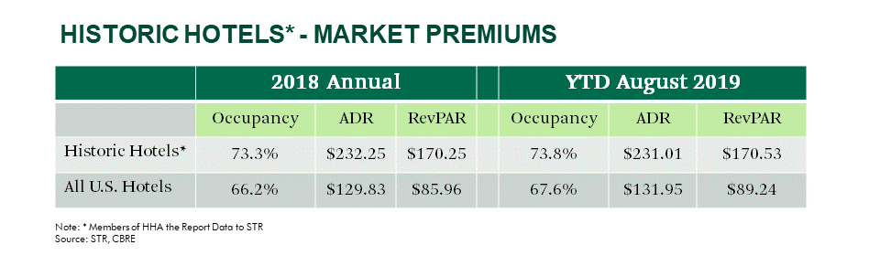

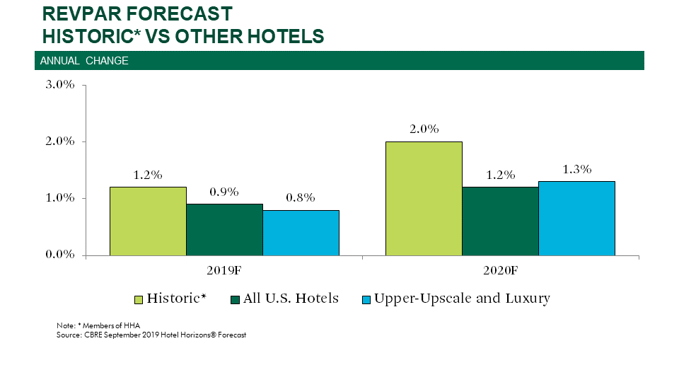
About Historic Hotels of America®
Historic Hotels of America is the official program of the National Trust for Historic Preservation for recognizing and celebrating the finest Historic Hotels. Historic Hotels of America has more than 300 historic hotels. These historic hotels have all faithfully maintained their authenticity, sense of place, and architectural integrity in the United States of America, including 44 states, the District of Columbia, the U.S. Virgin Islands, and Puerto Rico. Historic Hotels of America is comprised of mostly independently owned and operated historic hotels. More than 30 of the world’s finest hospitality brands, chains, and collections are represented in Historic Hotels of America. To be nominated and selected for membership into this prestigious program, a hotel must be at least 50 years old; has been designated by the U.S. Secretary of the Interior as a National Historic Landmark or listed in or eligible for listing in the National Register of Historic Places; and recognized as having historic significance. For more information, please visit HistoricHotels.org.

About CBRE Hotels
CBRE Hotels is a specialized advisory group within CBRE providing capital markets, consulting, investment sales, and research and valuation services to companies in the hotel sector. CBRE Hotels is comprised of more than 385 dedicated hospitality professionals located in 60 offices across the globe.

#########

MEDIA CONTACTS: Heather Taylor
Historic Hotels of America
Director, Marketing Communications
Tel: +1 202 772 8333 Fax: +1 202 772 8338
htaylor@historichotels.org

Robert Mandlbaum
CBRE
Director of Research Information Services
Tel: +1 404 812 5187 Fax:+1 404 842 1165
robert.mandelbaum@cbre.com

